INSTRUCTIONS FOR THE PREPARATION OF PAPERS
FOR the IBSCE – shanghai 2017

Author(s)
Company / Institute(s)
Address(es)

ABSTRACT: These notes provide important information on how to prepare and submit your paper. Read the notes carefully and follow them as precisely as possible. Any inaccuracy will cause delay in the publication of the Proceedings. Your paper must be written in English and the layout should be the same as this master document. In order to prepare your layout, save this document with a new name (please use your session code, e.g. 1AO.2.5 or 2BV.1.5, as the name for the document) and use it as a template and guide. Replace the text of this document with the text of your paper without changing the layout, font type and size, line spacing, page margins and structure of this template (see section 3). Do not insert page numbers and page headers/footers. If you have any question, please do not hesitate to contact us (see section 7.3).
Keywords: select 3 to 6 keywords from our list (see section 2.2).

1 DEADLINES AND DELIVERY

Papers will be published in the Proceedings only if the contributions are presented during the conference and if the files are correctly submitted through email by the presenting author or by one of the co-authors registered for the conference.
The electronic version of your paper must be submitted (see section 5, note 3) together with the Copyright Transfer Agreement Form duly filled-in and signed.

Your original manuscript must be delivered in the following formats:

- Microsoft Word (97/2003, .doc), and Adobe Acrobat PDF. Please save the file with your session code (e.g. 1AO.2.5 or 2BV.1.5).

Please make sure that the paper you submit is the final version with all numberings in the correct order.

2 PREPARING THE MANUSCRIPT

2.1 Volume and length of the paper
Please consider that the complete paper in pdf format, including illustrations, may not exceed 15 A4 pages and 600 Kb in size. This is a very good proven capacity for final papers. If your final pdf document size in Kb should be larger than this, verify the resolution and scale down the inserted images.

2.2 Organisation of the paper
The title of the paper should be informative and concise. It must be followed by the author(s) name(s) – listing the principal author first, organisation, complete address, telephone, fax and e-mail address. Title, authors and keywords must correspond to the ones indicated in the slides of presentation or in the poster, to avoid incongruities in the Proceedings.
No logos may appear in the title.
The abstract preceding the body of your paper should give a brief account of the most relevant aspects of your paper, in 100/200 words. Please avoid using symbols, graphics, formulas and text formatting (bold, italic, underline) in this part of the document.
Next, in order of importance, select three to six of the most relevant keywords from the ‘list of keywords’ (downloadable from the section ‘Instructions for authors’ of the website) and include them in your paper. The keywords should be separated with commas. The keywords must correspond exactly as they appear on our list. Add new keywords only in case no equivalent term is found on the list.
The body of the text must be in two columns. Number each heading using decimal numbering. Follow the layout specifications in section 3 below.

3 LAYOUT SPECIFICATIONS

The layout of your paper should have exactly the same format as this master document.
Before you start working on your paper, if you use Adobe Acrobat, select the printer option “Acrobat Distiller” (version 5.0) or Adobe pdf (version 6.0), in order to avoid accidental misplacement of layout elements afterwards when converting the Word file into PDF format.

3.1 Font type and size
Font type: Times New Roman. Font size: 9pt. Line spacing: single. Text alignment: justified left and right.
Captions should have the same font and size as the typeface used for the text. Make sure that illustrations are clear and easy to read. Please do not use any other font than Times New Roman

3.2 Page size
Page size must be A4 (210 mm x 297 mm).
Margins: top: 32mm; bottom:19mm; left and right: 25mm.
The body of the text must be in two equal columns of 73,6mm each. All written parts and images must fit inside these margins (for further details see subsection 4.1 about figures, and subsection 4.2 about tables).

3.3 Typing the text
Begin at the top of the first page with the title of the paper in bold capital letters and centered.
Leave one blank line between the title and the name of the author(s).
List the surname preceded by the initial of the first name; when several authors prepare a paper, the name of the main one should appear first. On the following lines, give the name of the company or institute, wherever applicable, with the full address; the name of each organisation should be easy to depict. This paragraph must be centered and without any blank space.
Next, leave two blank lines and then type an abstract of no more than 200 words (keep the indent of this block on both sides, as shown on this document). At the end of the abstract give your 3/6 keywords on the last line.
Leave two blank lines between the abstract and the body of the text of your paper, which must be in two columns.

3.4 Headings
Leave two blank lines before each section and one blank line before the heading of each sub-section. Headings and sub-headings should be numbered (e.g. 3, 3.1, 3.2). Separate the numbers from the text of the heading with two spaces.
There should be no blank line after the title of the sub-sections but only an indentation to indicate the beginning of a paragraph. Section headings should be in capital letters. Sub-section headings should be in upper and lower case. Headings should be normal text – not underlined or in bold.

4 ADDITIONAL COMPONENTS

4.1 Illustrations
Illustrations (photographs, drawings, graphs, charts, etc.) should not exceed 50% of the whole paper and should be placed as near as possible their citation. Illustrations must not be taken from previously-printed materials.
Illustrations should have a resolution of 300 dpi using simple colors (Standard+RGB) and be placed at 100% scale (i.e. if an illustration covers the full column width, it should be of approx. 860 pixel).
Illustrations should have the layout in line with the text (right click on the object – Format object – Layout – in line with the text, which should be the left-most option in the layout dialogue window).
All illustrations must be numbered progressively in bold decimals (e.g. Figure 1:) and have a reference in the text (e.g. Fig. 1). Captions should be as clear as possible, to allow comprehension of the illustration without reference to the text.
Graphs and charts must not be imported from Excel, but should be inserted as a picture (.jpg, .bmp or .gif). Please, use simple contrasting colors and effects instead of fill patterns. See Fig. 1 for good/bad example.
Illustrations must be clear also when printed in black and white.

Good example with contrasting colors:

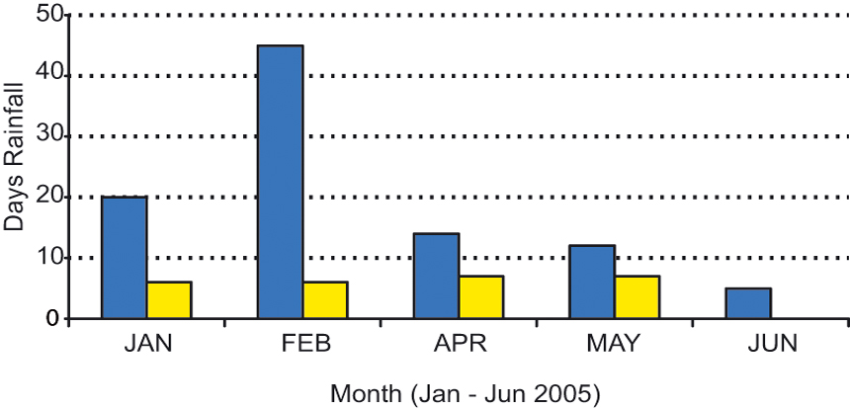

Bad example with fill patterns:

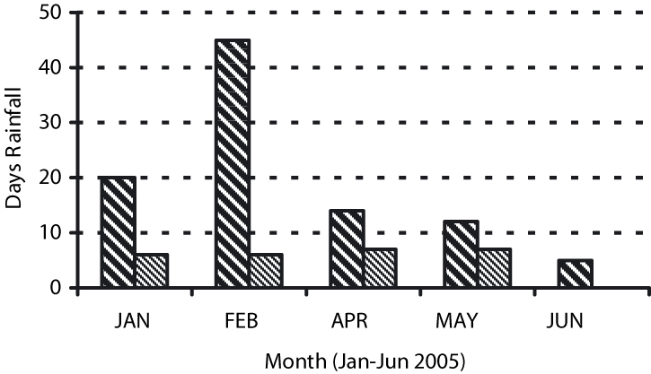

Figure 1: Clear line drawings are essential

4.2 Tables
Tabular presentation of data is an easy way to condense many items. Tables must be numbered in bold Roman numerals (e.g. Table I) , and have a reference in the text. Captions should be as clear as possible, for an easy comprehension of the tables.

Table I: Sample of installed PV Systems Sizes and Costs

Country Size (Wp) Price (US$)
China 10 93
Kenya 40 800
The Gambia 15 560

4.3 References and notes
References and notes must not appear as footnotes in the pages, but should be listed together at the end of the text, in the dedicated sections.
When referring to them in the text, please type the corresponding reference number in brackets. Use round brackets for the notes (1) and square brackets for the references [1].
To make them easier to find, indent your notes and references from the second line, as in the examples (see sections 5 and 6).

4.4 Acknowledgements
Any acknowledgement should be added at the very end of the paper, in a dedicated section, as in the example (see section 8).

5 NOTES

  - This section should have the progressive number before the title, exactly as for the previous ones.
  - Do not add any unnecessary space between the listed numbers of your notes.
  - The final slides of presentation or the final poster and the final paper to be included in the Proceedings, together with the copyright transfer agreement form, should be sent by email to papers@ibsce.com (or by dropbox or other link for download) by 21 April 2017.

6 REFERENCES

[1] This section should have the progressive number before the title, exactly as for the previous ones.
[2] Do not add any unnecessary space between the listed numbers of your references.
[3] J. Doe, Proceedings of the 3rd Biomass Conference –Energy, Industry and Climate Protection, III Vol. (2005), pag. 981.
[4] D. Red, Evaluation of Bioenergy Systems in the Southern regions in Nigeria, (2007), pag. 124.
[5] O. Green, Biomass Energy Production in central Italy, (2008), pag 45.

7 OTHER POINTS

7.1 Permissions
Authors are fully responsible for their manuscripts. They must take the necessary steps to obtain permission for using any material that might be protected by copyright.

7.2 Copyright
Please be aware that on delivery of your paper, presentation / poster, you transfer the copyright to ETA-Florence Renewable Energies, publisher of the proceedings.

7.3 Further information
We are available to assist you. Please, do not hesitate to contact us for any query; please address your e-mails to papers@ibsce.com or call +39 - 055 -500 2280.

8 IMPORTANT SPECIFICATIONS FOR THE PDF

8.1 Printer
If you are using Adobe Acrobat, please select Acrobat Distiller (version 5.0) or Adobe Pdf (version 6.0) as printer option to convert your Word file into pdf format. Go to Printer Properties and click on “Acrobat pdf settings”; in Conversion Settings select “Press” quality.
If you are using special fonts make sure that the checkbox “Do not send fonts to distiller (“adobe pdf” for version 6.0)” is not selected.

8.2 Password / Security
Please do not use any Password / Security when making the Pdf file. As the header and page numbers will be added by us, we need to ensure that you pdf file is not password protected.

9 ACKNOWLEDGEMENTS

- We thank you for successfully following these instructions. This will make the Delivery easier and avoid delays in the publication of the Proceedings!
- The Authors are grateful to the students of our Faculty for their helpful cooperation
- The President of …….

10 LOGO SPACE

If you wish, you may add your logos (e.g. Organisations, Project Partners, Supporters, Brands etc) at the end of the paper.

